

Railway Stations



SUBMITTED BY:

TAHREEM FATIMA (3872)

TASHFEEN AHMED (3869)

MOBEENA RAMAZAN (3868)

NOOR UL HUDA (3847)

LAIBA BINTE MAZHAR (3870)

**INTRODUCTION:**

Railway is the cheapest source of transport. Thousands of people use railway on daily bases to travel from one place to another and hundred of employees are working in one station. Passengers reserve ticket on the bases of ‘station to’ to ‘station from’.

As it is difficult to store and maintain old and new records manually so we are designing database to make our work of holding records more convenient and maintain records with more accuracy.

There are lot of conflicts which are reduced by maintaining database as it provides many facilities

* by maintaining safe records
* searching of data would be much easier by this
* By entering the data faster

Through this error of the information recorded in the system will be minimized while entering to system and database is also user friendly.

**Our Aim:**

The aim of case study is to design and develop a database maintaining the records of different trains, train status, employees and passengers. This collection of data is typically organized to model aspects of reality in a way that supports processes requiring information.

**Business Function:**

**For Passengers details:**

* Firstly, the passenger will reserve his ticket for travelling through ticket through ticket boot.
* Passenger can control his ticket if he doesn’t want to travel but if he cancel his ticket a day before then half of the prize will be returned to him/her. but if he miss his train then no prize will be returned.

**Ticket Booking:**

According to passenger choice following process will carry on in booking ticket.

* Check seat availability in certain status of train.
* Status of train will be recorded.
* Arrival and departure of train will be managed.
* Each passenger will give a unique id for traveling through certain train.
* Schedule of train access different cities.

**Ticket cancellation:**

If passenger cancel his booking because of any issue certain things will be handled.

* Station route of him will be recorded.
* Record seat no of passenger who cancel his booking station.

**Routes Detail:**

* Station information of passenger.
* Record the source and destination of specific station.

**Fare detail:**

* According to selected station of passenger fares will calculated.

Fares may vary as passenger book the class of train such as economy, business class and first class.

**RULES:**

1. Your luggage should wait under following terms.

* Economy= 40kg
* First= 50,100
* Business= 70kg for free and maximum of 150kg (if he pays extra).

(If you want to exceed the limit then you must pay 200 per kg)

1. Half fare will be applied to kids between 3 to 10 years of age and old citizens of age 65 and above.
2. A railway record system must maintain a list of employees who are qualified for the employee occupation category
3. People who belong to navy, military, air force will have an 80% discount on their tickets.
4. Time must be managed in a way that number of arriving trains must be less than or equal to number of tracks.
5. The in between stoppage station and their reservation are not considered.
6. Only three categories of tickets can be reserved i.e. first class, business class, economy.
7. Every employee will have a duty for 12 hours per day. (night shift, day shift)
8. Route details will be shown on large led on the station.
9. Arrival and departure timings of train are normally announced as:

* 10 minutes before
* 5 minutes before
* 1 minute before

**User and roles:**

**Users:**

* Station master
* Sub-station master
* Booking clerk
* Phone enquiry clerk
* Controller

**Roles**

* **Station master:** he can view or edit all data of passengers, trains, tickets, employees, station and other entities because he manages all the activates of the station and also assign jobs to employees.
* **Sub-station master:** he can view or edit all data of passengers, trains, tickets, employees, station and other entities expect for his own data because he works as you can say right hand or station master.
* **Booking clerk:** He can get to reserve or cancel seat in a train for passengers and print ticket for them on booth. But he cannot edit or view data of old passengers and employees.
* **Phone enquiry clerk:** he can view data of trains (arrival or departure of train) because he accepts the calls of the peoples who want to know the timings of train for any reason.
* **Controller:** he can edit and view details of trains and stations because **he** allot time to trains that manage for each of the arrival of train that number of trains at one station must be equal to tracks on trains so nobody faces any inconvenience.

**DATA FLOW:**

**Entity:**

1. passenger
2. employee
3. train
4. station
5. ticket

**Attributes:**

1. PASSENGER:
2. Full name
3. Mobile number
4. CNIC
5. Gender
6. Seat number
7. Age
8. EMPLOYEE:
9. Serial number
10. First name
11. Last name
12. ID
13. Password
14. CNIC
15. Gender
16. Age
17. email
18. address
19. mobile number
20. city, state
21. qualification
22. TRAIN:
23. Train name
24. From station
25. To station
26. Arrival time
27. Departure time
28. No of Seats
29. Tarin id
30. routes
31. STATION:
32. Name
33. Number
34. Number of trains
35. Halting trains
36. Arrival time
37. Number of employees
38. Number of canteens
39. Number of washrooms
40. Number of booths
41. TICKET:
42. Train number
43. Seat number
44. Passenger name
45. From station
46. To station
47. class

**Relationship:**

1. **passengers** reserve **tickets**
2. **train** stops at certain **station.**
3. **Passenger** cancels the **ticket.**
4. **Train** starts from source **station** and ends at destination **station.**
5. **Employee** confirms **passenger**’s reserved **ticket.**
6. **Passenger** travels in **train.**
7. **Employee** works at **station**.
8. **Employee** manage **train** activity.

**Constraints:**

1. Your luggage should wait under following terms.

* Economy= 40kg
* First= 50,100
* Business= 70kg for free and maximum of 150kg (if he pays extra).

(If you want to exceed the limit then you must pay 200 per kg)

**Entity:** passenger

**Event:** insert

**Condition:** should not exceed limit

**Action:** will check and if exceed limits then passenger should remove some or pays extra as per kg.

1. Half fare will be applied to kids between 3 to 10 years of age and old citizens of age 65 and above.

**Entity:** passenger

**Event:** insert

**Condition:** age conformation will be done through ID.

**Action:** Fine will be charged else ticket will be canceled (if he is on the moving train then he had to hault on next station).

1. People who belong to navy, military, air force will have an 80% discount on their tickets.

**Entity:** passenger

**Event:** update if travelled before in train else insertion

**Condition:** conformation of person status in forces through charge card (specific card for forces)

**Action:** if he fails to prove his identity in forces then he will be charged a full fare.

1. A railway record system must maintain a list of employees who are qualified for the employee occupation category

**ENTITY:** employee

**EVENTS:** insert

**CONDITION:** every employee’s qualification should met the criteria.

**ACTION:** a candidate would not be hired for specified job.

1. Time must be managed in a way that number of arriving trains must be less than or equal to number of tracks.

**ENTITY:** employee.

**EVENTS:** update.

**CONDITION:** one track will be managed for a single train at a time.

**ACTION:** if controller fails to manage train timings then there will be no route to park the train and it will result in an accident.

1. The in between stoppage station and their reservation are not considered.

**ENTITY:** station, ticket, passenger.

**EVENT:** insert.

**CONDITION:** passenger has no concern of in between stations and their reservations.

**ACTION:** if a passenger leaves the train before its destination station no refund will be there.

1. Only three categories of tickets can be reserved. i.e. first class, business class, economy

**EVENT:** update

**ENTITY:** ticket, train.

**CONDITION:** confirmation of ticket class at the time of being reserved.

**ACTION:** If a person wants to change class then it can be updated with a 5% charge / interest.

1. Every employee will have a duty for 12 hours per day. (night shift, day shift)

**ENTITY:** employee

**EVENTS:** update

**CONDITION:** if an employee done 12 hours duty then he must be free.

**ACTION:** if not done his duty without leave deduction of pay or given threat.

1. Route details will be shown on large led on the station

**ENTITY:** station, train.

**EVENT:** update, delete.

**CONDITION:** current route details should be updated after 12 hours and previous data is deleted.

**ACTION:** backup plan should be there if led got damaged.

1. Arrival and departure timings of train are normally announced as :
2. 10 minutes before
3. 5 minutes before
4. 1 minute before

**ENTITY:** station, employee.

**EVENT:** update

**CONDITION:** announcements should be on time.

**ACTION:** the employee should avoid delay or manage some other person on his place if he is not able to fulfil his task of arrival and departure announcements.

**DOMAIN OF ATTRIBUTES:**

**Passenger:** (full name, phone number, CNIC, gender, seat number, age)

1. **full name : (**simple , single valued , not derived)
2. **Name :** full name
3. **Meaning:** name of passenger who booked ticket
4. **Data type:** short text
5. **Length :** -
6. **Format :** upper case letters
7. **Range:**  -
8. **Allowable value: -**
9. **Uniqueness:** no
10. **Null support**: no
11. **Phone number:** (simple , single valued , not derived)
12. **Name :** phone number
13. **Meaning:** phone number of passenger that is in use.
14. **Data type:** number
15. **Length :** 12
16. **Format :** 0000-0000000
17. **Range:**  -
18. **Allowable value:**  -
19. **Uniqueness:** unique
20. **Null support**: no
21. **CNIC:** (simple , single , not derived)
22. **Name:** CNIC
23. **Meaning:** id number of the passenger
24. **Data type:** number
25. **Length:** 15
26. **Format:** 00000-0000000-0
27. **Range:** -
28. **Allowable value:** -
29. **Uniqueness:** yes
30. **Null support:** yes
31. **Gender:** (simple , single , not derived)
32. **Name:** gender
33. **Meaning:** male / female (type of passenger)
34. **Data type:** short text
35. **Length:** -
36. **Format:** -
37. **Range:** -
38. **Allowable value:** male or female
39. **Uniqueness:** no
40. **Null support:** yes
41. **Seat number:**( composite , single value , not derived)
42. **Name:** seat number
43. **Meaning:** number of seat allotted to passenger
44. **Data type:** text
45. **Length: 6**
46. **Format:** L-00000
47. **Range:** 0-9 / a-c
48. **Allowable value:**  -
49. **Uniqueness:**  yes
50. **Null support:** no
51. **Age:** (simple , single value , not derived)
52. **Name:** age
53. **Meaning:** age of passenger
54. **Data type:** numbe**r**
55. **Length:** -
56. **Format:** -
57. **Range: -**
58. **Allowable value: -**
59. **Uniqueness:** no
60. **Null support:** yes

**TRAIN: (**train name, **train id**, from station, to station, arrival time, departure time, arrival date, departure date, no of seats)

**Train name:** secondary key (candidates) (alternative key)

**Train id:** primary key(candidates)

**From station:** secondary key

**To station:** secondary key

**Arrival time:** secondary key

**Departure time:** secondary key

**Arrival date:** secondary key

**Departure date:** secondary key

**No of Seats:** secondary key

1. **Train name: (**simple , single , not derived)
2. **Name :**train name
3. **Meaning: every** train in the station have the specific name we usually specify by it.
4. **Data type :**character
5. **Length:** 255
6. **Format:** N/A
7. **Range :**A-Z character
8. **Allowable values:** N/A
9. **Uniqueness :**yes
10. **Null support:** No
11. **From station (**simple , single , not derived)
12. **Name :**from station
13. **Meaning:** arrival or departure of train from the station
14. **Data type :**text
15. **Length:** N/A
16. **Format:** N/A**.**
17. **Range:-** N/A
18. **Allowable values:-** N/A
19. **Uniqueness :**yes
20. **Null support :**no
21. **To station (**simple , multi value , not derived)
22. **Name :**to station
23. **Meaning :**departure and arrival of train from the station
24. **Data type :**text
25. **Length:-** N/A
26. **Format:-** N/A
27. **Range:-** N/A
28. **Allowable values:-** N/A
29. **Uniqueness :**yes
30. **Null support :**no
31. **Train id:** (composite , single valued , not derived)
32. **Name :**train id
33. **Meaning :**every train have the specific id from which we usually secify it
34. **Data type :**,number
35. **Length:**12
36. **Format:**999-999999-999
37. **Range:**0-9
38. **Allowable values**:{0,1,2,3,4,5,6,7,8,9}
39. **Uniqueness :**yes
40. **Null support :**no
41. **No of Seats (**composite , multi value , not derived)
42. **Name :**no of seats
43. **Meaning :**the number of seats in train let people know about the seating structure
44. **Data type :**text
45. **Length:**6
46. **Format:**L-00000
47. **Range:**0-9,A-Z character
48. **Allowable values :** N/A
49. **Uniqueness :** yes
50. **Null support :**no
51. **Arrival time (**simple , single , derived from to station and from station)
52. **Name :**arrival time
53. **Meaning :**the time in which the train arrives
54. **Data type :**text
55. **Length:**4
56. **Format:**00:00
57. **Range:**0-9
58. **Allowable values**: N/A
59. **Uniqueness :**no
60. **Null support :**no
61. **Departure time (**composite , single , derived from to station and from station)
62. **Name :**departure time
63. **Meaning :**time in which train depart the station
64. **Data type :**text
65. **Length:**4
66. **Format:**00:00
67. **Range**:0-9
68. **Allowable values**: N/A
69. **Uniqueness :**no
70. **Null support :**no
71. **Arrival date (**composite , multi value , not derived)
72. **Name :**Arrival date
73. **Meaning :**date in which train arrives the station
74. **Data type :**text
75. **Length:**8
76. **Format:**09/09/0000
77. **Range:**0-9
78. **Allowable values**: N/A
79. **Uniqueness :**no
80. **Null support :**no
81. **Departure date (**composite , multi value , not derived)
82. **Name :**departure date
83. **Meaning :**date in which train depart at the station
84. **Data type :**text
85. **Length:**8
86. **Format:**09/09/0000
87. **Range:**0-9
88. **Allowable values**: N/A
89. **Uniqueness :**no
90. **Null support :**no

**TICKET:** (Ticket id, Seat No, Passenger Name, from station, To Station, class)

1. **ID:** (composite , single value , not derived)
2. **Name :**Ticket id
3. **Meaning :"**every ticket will have its own ID**"**
4. **Datatype** :number
5. **Length**:12
6. **Forma**t: 999-999999-999(station from no. - 000000- station To no.)
7. **Range**:0-9
8. **Allowable valu**e:-----
9. **Uniqueness** :yes
10. **Null support**: no

1. **Seat no:** (composite , single value , not derived)
2. **Name** :Seat No
3. **Meaning**: seat no of a passenger will be mention on ticket"
4. **Datatype** :text
5. **Length**: 6
6. **Format**:L-00000(class-00000)
7. **Range**:0-9,A-C
8. **Allowable Value**:----
9. **Uniqueness** : "yes"
10. **Null Support** :"No"

1. **Passenger Name:** (composite , single value , not derived)
2. **Name** :Pass name
3. **Meaning** :"passengers name on ticket"
4. **Datatype** : Long text
5. **Length**:---
6. **format**: First name middle name last name)
7. **Range**: A-Z
8. **Allowable values**:-----
9. **Uniqueness** :No
10. **Null support**: No

1. **From station**: (simple , single , not derived)
2. **Name**: From station
3. **Meaning** :"departure of train from which station"
4. **Datatype** :Text
5. **Length**:----
6. **Format**: station No-station name
7. **Range**:-----
8. **Allowable values**:-----
9. **Uniqueness** :yes
10. **Null support**: yes

1. **To station**: (simple , multi value , not derived)
2. **Name** : To station
3. **Meaning** :"Arrival of train from which station"
4. **Datatype** :Text
5. **Length**:----
6. **Format**: station No-station name
7. **Range**:-----
8. **Allowable values**:-----
9. **Uniqueness** :yes
10. **Null support**: yes

1. **CLASS** : (simple , multi value , derived from seat no)
2. **Name**: ticket class
3. **Meaning** :"which type of ticket a passenger will take"
4. **Datatype** :text
5. **Length**: ---
6. **Format** : L
7. **Range** :A-C
8. **Allowable values**:{economy, business, first}
9. **Uniqueness** : yes
10. **Null support** :yes

**Employees:**

1. **First Name: (**Simple**,** Single Valued, Derived)
2. Name: First name
3. Meaning: Every employee will have his name recorded in database
4. Data Type: Short Text
5. Length: 10
6. Format: ??????????
7. Range: A-Z
8. Allowable values: N/A
9. Uniqueness: “No”
10. Null Support: “No”
11. **Last Name: (**Simple**,** Single Valued**,** Derived)

1. Name: Last name
2. Meaning: Every employee will have his name recorded in database
3. Data Type: Short Text
4. Length: 10
5. Format: ??????????
6. Range: A-Z
7. Allowable values: N/A
8. Uniqueness: “No”
9. Null Support: “No”
10. **CNIC: (**Simple**,** Single Valued**,** Not Derived_
11. Name: The Computerized National Identity card number (CNIC)
12. Meaning: Every employee will have his own unique Id number
13. Data Type: Number
14. Length: 15
15. Format: 99999-9999999-9
16. Range: 1-15
17. Allowable values: N/A
18. Uniqueness: “Yes”
19. Null Support: “No”
20. **Qualification:** (Simple, Single Valued, Not Derived)
21. Name: Qualification
22. Meaning: Every employee should meet the qualification requirement for his particular job
23. Data Type: Short Text
24. Length: 15
25. Format: N/A
26. Range: A-Z
27. Allowable values: N/A
28. Uniqueness: “No”
29. Null Support: “No”
30. **Experience: (**Simple**,** Single Valued**,** Not Derived)
31. Name: Experience
32. Meaning: Every employee should have the experience required for his particular job
33. Data Type: Short Text
34. Length: 7
35. Format: 99LLLLL
36. Range: N/A
37. Allowable values: N/A
38. Uniqueness: “No”
39. Null Support: “No”
40. **Designation: (**Simple**,** Single Valued**,** Not Derived)
41. Name : Designation
42. Meaning : For letting know employee’s status at work
43. Data Type: Short Text
44. Length: 20
45. Format: N/A
46. Range: A-Z
47. Allowable values: N/A
48. Uniqueness: “No”
49. Null Support: “No”
50. **Mobile Number: (**Composite**,** Single Valued**,** Not Derived)
51. Name : Mobile Number
52. Meaning: This will be required for contact purpose
53. Data Type: Number
54. Length: 13
55. Format: 00-9999999999
56. Range: 0-9
57. Allowable values: N/A
58. Uniqueness: “Yes”
59. Null Support: “No”
60. **E-mail:** (Composite, Multi Valued, Not Derived)
61. Name : Email
62. Meaning: This will be required for contact purpose
63. Data Type: Short Text
64. Length: 50
65. Format: N/A
66. Range: N/A
67. Allowable values: N/A
68. Uniqueness: “Yes”
69. Null Support: “Yes”
70. **Gender: (**Simple**,** Single Valued**,** Not Derived)
71. Name : Gender
72. Meaning :Employee’s Type
73. Data Type: Short Text
74. Length: 6
75. Format: ??LLLL OR LLLL
76. Range: N/A
77. Allowable values: {female, Male}
78. Uniqueness: “No”
79. Null Support: “Yes”
80. **Age: (**Simple**,** Single Valued**,** Derived)
81. Name : Age
82. Meaning : For Employee’s Info
83. Data Type: Number
84. Length: 3
85. Format: 999
86. Range: 0-9
87. Allowable values: {0,1,2,3,4,5,6,7,8,9}
88. Uniqueness: “No”
89. Null Support: “No”
90. **Serial Number: (**Simple**,** Single Valued**,** Not Derived)
91. Name : Serial Number
92. Meaning :Unique serial number is assigned to each employee so we can identify him easily
93. Data Type: Number
94. Length: 5
95. Format: 99999
96. Range: 0-9
97. Allowable values: N/A
98. Uniqueness: “Yes”
99. Null Support: “No”
100. **D.O.B: (**Composite**,** Multi Valued**,** Not Derived)
101. Name : D.O.B
102. Meaning : For Employee’s additional info
103. Data Type: Short Text
104. Length: 20
105. Format: N/A
106. Range: 0-9 , A-Z
107. Allowable values: N/A
108. Uniqueness: “No”
109. Null Support: “No”
110. **Address: (**Composite**,** Multi Valued**,** Not Derived)
111. Name : Address
112. Meaning : For Employee’s contact information
113. Data Type: Short Text
114. Length: 50
115. Format: N/A
116. Range: N/A
117. Allowable values: N/A
118. Uniqueness: “No”
119. Null Support: “No”

Employee( First name, Last Name, CNIC, Qualification, Experience, Serial Number Age, Gender, E-mail, Address, Designation, Mobile Number)

Secondary: Age, Gender, Designation, First Name, Last Name

**Candidates:**

Primary (Alternate): CNIC

Primary: Serial Number

**Station:**

1. **Name of station: (**Simple, Single valued, Not derived)

|  |  |
| --- | --- |
| 1. **Name:** | Name of station |
| 1. **Meaning:** | To list name of stations because we usually identify stations by their names. |
| 1. **Data Type:** | Characters |
| 1. **Length:** | 255 |
| 1. **Format:** | N/A |
| 1. **Range:** | All Upper case letters |
| 1. **Allowable Values:** | N/A |
| 1. **Uniqueness:** | Yes |
| 1. **Null Support:** | No |

1. **No of train’s starts: (**Simple, Single valued, Not derived)

|  |  |
| --- | --- |
| 1. **Name:** | No of trains starts |
| 1. **Meaning:** | How many trains will start from this station to begin their journey every day. |
| 1. **Data Type:** | Numbers |
| 1. **Length:** | 3 |
| 1. **Format:** | 099 |
| 1. **Range:** | 0 to 999 |
| 1. **Allowable Values:** | N/A |
| 1. **Uniqueness:** | No |
| 1. **Null Support:** | yes |

1. **No of trains halt: (**Simple**,** Single valued**,** Not derived)

|  |  |
| --- | --- |
| 1. **Name:** | No of trains halt |
| 1. **Meaning:** | How many station will halt/stop on that station every day and then continue their journey. |
| 1. **Data Type:** | Number |
| 1. **Length:** | 3 |
| 1. **Format:** | 099 |
| 1. **Range:** | 0 to 999 |
| 1. **Allowable Values:** | N/A |
| 1. **Uniqueness:** | No |
| 1. **Null Support:** | Yes |
|  |  |

1. **No of employee: (**Simple**,** Single valued**,** Not derived)

|  |  |
| --- | --- |
| 1. **Name:** | No of employee |
| 1. **Meaning:** | Total number of employees working on one specific station (this includes all status employee). |
| 1. **Data Type:** | Number |
| 1. **Length:** | 5 |
| 1. **Format:** | 09999 |
| 1. **Range:** | 1 to 99999 |
| 1. **Allowable Values:** | N/A |
| 1. **Uniqueness:** | No |
| 1. **Null Support:** | No |

1. **No of booths: (**Simple, Single valued**,** Not derived)

|  |  |
| --- | --- |
| 1. **Name:** | No of booths |
| 1. **Meaning:** | Number of booths in one station (example: ticket booth, helping booth or security booth etc.) |
| 1. **Data Type:** | Number |
| 1. **Length:** | 3 |
| 1. **Format:** | 099 |
| 1. **Range:** | 1 to 999 |
| 1. **Allowable Values:** | N/A |
| 1. **Uniqueness:** | No |
| 1. **Null Support:** | No |

1. **Address: (**Simple, Multi valued, not derived)

|  |  |
| --- | --- |
| 1. **Name:** | Address |
| 1. **Meaning:** | Address of the station where station is located exactly so that anyone can reach there. |
| 1. **Data Type:** | Characters, numbers |
| 1. **Length:** | 85 |
| 1. **Format:** | District, city, province |
| 1. **Range:** | N/A |
| 1. **Allowable Values:** | N/A |
| 1. **Uniqueness:** | Yes |
| 1. **Null Support:** | No |

1. **City: (**Simple**,** Single valued**,** Derived (from address attribute))

|  |  |
| --- | --- |
| 1. **Name:** | City |
| 1. **Meaning:** | City in which station is located |
| 1. **Data Type:** | Characters |
| 1. **Length:** | 50 |
| 1. **Format:** | N/A |
| 1. **Range:** | All lower case letters |
| 1. **Allowable Values:** | N/A |
| 1. **Uniqueness:** | No |
| 1. **Null Support:** | No |

1. **Province: (**Simple**,** Single valued**,** Derived (from address attribute))

|  |  |
| --- | --- |
| 1. **Name:** | Province |
| 1. **Meaning:** | Province in which station is located |
| 1. **Data Type:** | Characters |
| 1. **Length:** | 50 |
| 1. **Format:** | N/A |
| 1. **Range:** | All lower case letters |
| 1. **Allowable Values:** | N/A |
| 1. **Uniqueness:** | No |
| 1. **Null Support:** | No |

1. **No of tracks: (**Simple**,** Single valued**,** Not derived)

|  |  |
| --- | --- |
| 1. **Name:** | No of tracks |
| 1. **Meaning:** | Number of total tracks present in one station on which trains can park. |
| 1. **Data Type:** | Numbers |
| 1. **Length:** | 3 |
| 1. **Format:** | 099 |
| 1. **Range:** | 1 to 999 |
| 1. **Allowable Values:** | N/A |
| 1. **Uniqueness:** | No |
| 1. **Null Support:** | No |

1. **Owner: (**Simple**,** Single valued**,** Not derived)

|  |  |
| --- | --- |
| 1. **Name:** | Owner |
| 1. **Meaning:** | Who is the owner of specific station |
| 1. **Data Type:** | Characters |
| 1. **Length:** | 225 |
| 1. **Format:** | N/A |
| 1. **Range:** | All lower case letters |
| 1. **Allowable Values:** | {ministry of railway, government of Pakistan} |
| 1. **Uniqueness:** | No |
| 1. **Null Support:** | No |

1. **Inquiry phone number: (**Simple, Single valued, Not derived)

|  |  |
| --- | --- |
| 1. **Name:** | Inquiry phone number |
| 1. **Meaning:** | The phone number on which any person can call to get detail about the train timings or station or complain or any other kind of information. |
| 1. **Data Type:** | Numbers |
| 1. **Length:** | 11 |
| 1. **Format:** | 000-99999999 |
| 1. **Range:** | 000-00000000 to 999-99999999 |
| 1. **Allowable Values:** | N/A |
| 1. **Uniqueness:** | Yes |
| 1. **Null Support:** | No |

1. **No of platform in use: (**Simple, Single valued, Not derived)

|  |  |
| --- | --- |
| 1. **Name:** | No of platform in use |
| 1. **Meaning:** | The number of platform in use from which passengers can get into or get out of the train and can have convenient access to train easily. |
| 1. **Data Type:** | number |
| 1. **Length:** | 3 |
| 1. **Format:** | 099 |
| 1. **Range:** | 1 to 999 |
| 1. **Allowable Values:** | N/A |
| 1. **Uniqueness:** | No |
| 1. **Null Support:** | No |

**Keys:**

STATION(Name of station, No of train’s starts, No of trains halt, No of employee, No of booths, Address, City, Province, No of tracks, Owner, Inquiry phone number, No of platform in use)

|  |  |
| --- | --- |
| **Name of station** | Primary key |
| **No of train’s starts** | Secondary key |
| **No of trains halt** | Secondary key |
| **No of employee** | Secondary key |
| **No of booths** | Secondary key |
| **Address** | Secondary key |
| **City** | Secondary key |
| **Province** | Secondary key |
| **No of tracks** | Secondary key |
| **Owner** | Secondary key |
| **Inquiry phone number** | Secondary key |
| **No of platform in use** | Secondary key |

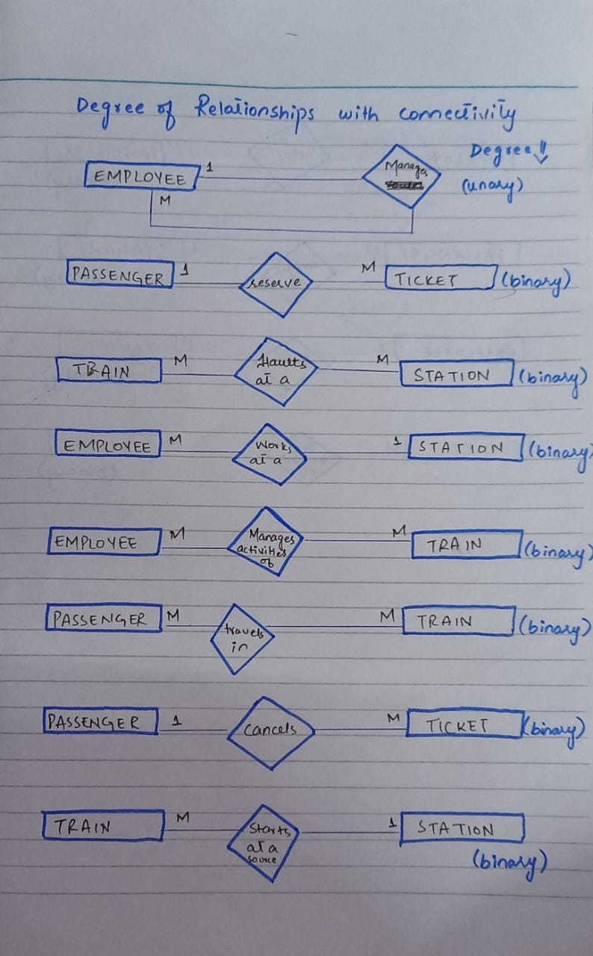

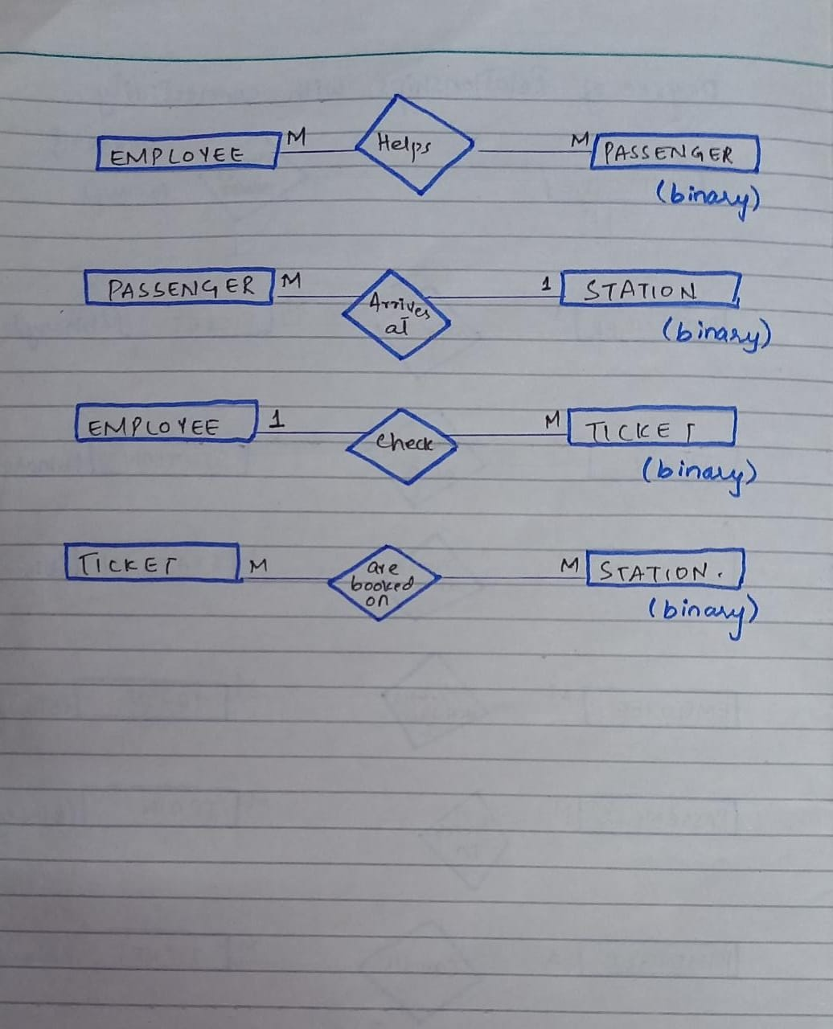

TRAIN

